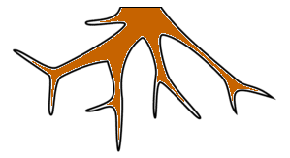

Raiz

⠠⠗⠁⠊⠵

Caule

⠠⠉⠁⠥⠇⠑

Folha

⠠⠋⠕⠇⠓⠁

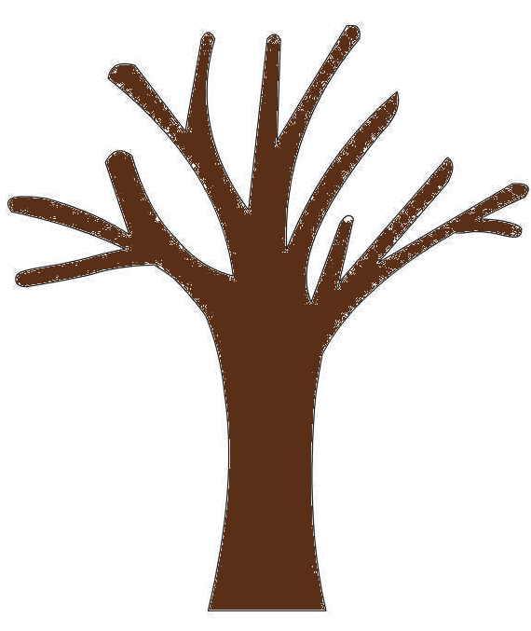

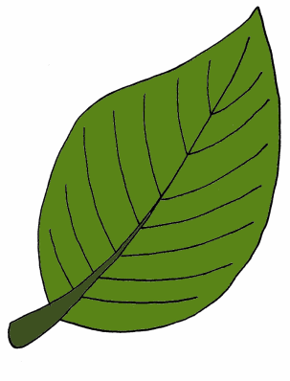

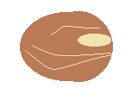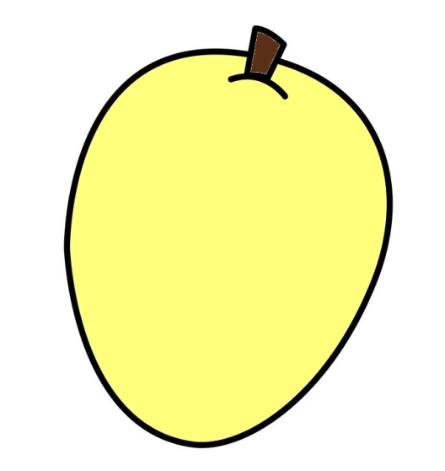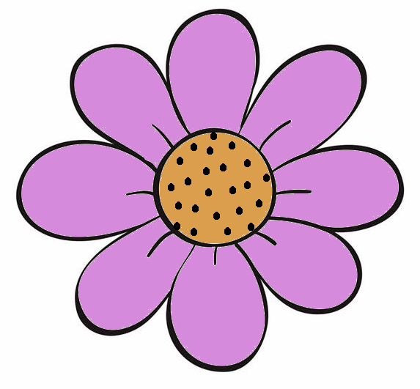

Fruto

⠠⠋⠗⠥⠞⠕

Flor

⠠⠋⠇⠕⠗

Semente

⠠⠎⠑⠍⠑⠝⠞⠑